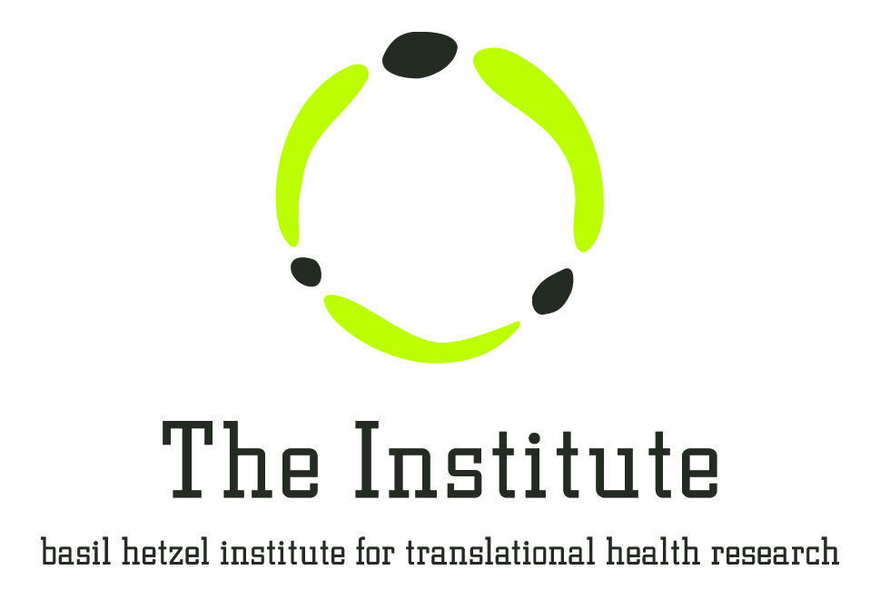
Work Experience Enquiry Form

The Basil Hetzel Institute for Translational Health Research

Work Experience is a structured range of activities provided by an employer to enable a student to experience (first hand) the basic aspects of a particular job. This will be a part of a program that is formally integrated into secondary education. Work experience with The Basil Hetzel Institute for Translational Health Research (BHI) is voluntary – you will not receive payment.
Placements are based at The Institute, part of The Queen Elizabeth Hospital campus in Woodville South Australia. You will be required to wear fully enclosed shoes when in the laboratories, but all other safety equipment and clothing will be provided.
NOTE: This form is designed to help us explore opportunities for you to undertake work experience within the Institute. Placement requests need to be formally supported by your school. Your request does not guarantee a work experience arrangement at BHI.
1. Personal Details
Name (in full):
Contact Phone Number:
Email Address:
2. Study Details
Secondary Students:
School Name:
Year Level:
Is this compulsory high school work experience? YES NO
Your school’s Workplace Learning Agreement form will be required once accepted to BHI for a work experience placement.
3. Placement Details
At the BHI there are a range of departments conducting health and medical research. Please check our website www.basilhetzelinstitute.com.au and indicate if you have a particular interest.
What are your career goals, and how will work experience link to your current study?:
Do you have a specific interest in a field or group to work with or a general interest?:
Preferred Dates:
4. Additional Information
Any other information you would like us to know?:

If you have a resume, please attach it with this form and send to: imogen.ball@sa.gov.au
OR hardcopy: Imogen Ball, BHI Facility Manager, DX465101 The Queen Elizabeth Hospital, 28 Woodville Rd, Woodville SA 5011.

